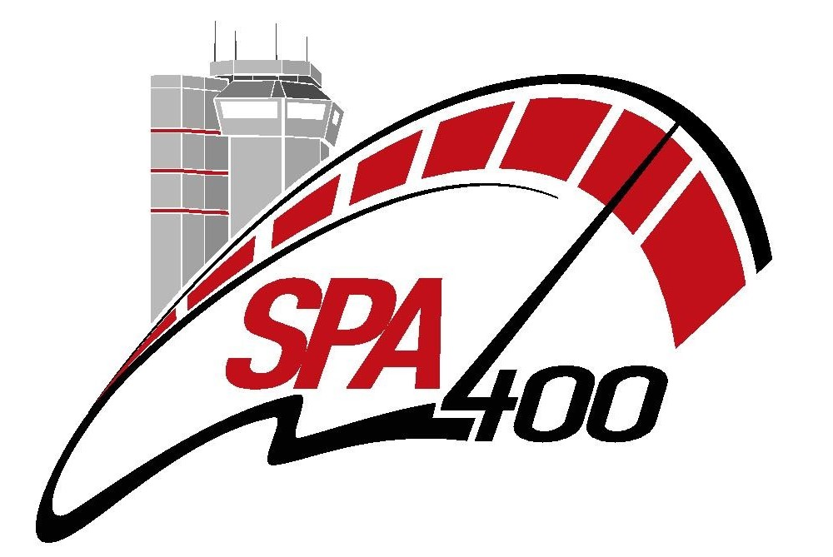
Media Accreditation Request
Spa 400 – 13-14-15 April 2018

SURNAME:
FIRST NAME:
ADDRESS:
DATE OF BIRTH:
ID CARD OR PASSPORT N°:
E-MAIL:
MOBILE:

FUNCTION: JOURNALIST - PHOTOGRAPHER - CAMERAMAN
(Circle the appropriate function)

MEDIA:
TYPE: Written Press/Newspaper - Magazine - Television - Video - Radio - Internet
(Circle the appropriate type)
MEDIA ADDRESS:
EDITOR-IN-CHIEF:
TEL:
E-MAIL:

I, the undersigned wish under my own initiative and own responsibility to carry out my activity on and around the Spa-Francorchamps circuit, and this at my own risk and peril.
I irrevocably renounce for myself and all my beneficiaries of all recourse, of any kind whatsoever, against: the circuit’s owner(s) and/or operator (s), the meeting’s organiser (s), the circuit’s participants and users, the competitors and owners (or holders) of the participating vehicles, the voluntary officials and other official representatives, the insurers of individuals (or organisations) referred to hereinabove for any damage of any kind I might be subjected to in the course of the aforementioned event. In the event of death, the present waiver of recourse also contains strong commitment of safe haven for my beneficiaries, my heirs, next of kin and our insurers.

I acknowledge to be responsible for any damages caused by myself as also for those my responsibility might be brought into question.
I testify that I am covered by an individual Third-Party Liability insurance (via my professional activity or as member of a Not-For-Profit Organisation (proof of cover by the president of the NPO to be provided.)
I declare having taken note of the rules regulating the event and commit unreservedly to respect same. I certify that the above-mentioned details are correct.

Hereby with this request I confirm the commitment to publish an article or a photographic reportage or other of the event.

Date and signature preceded by the words “read and approved”.

- The request for accreditation document must compulsorily be fully completed with the requested information.
- One request document per person wishing to carry out his/her activity during the meeting.
- The requests for accreditations from official bodies must be on the publication’s or the photo agency’s headed letter paper. These must be signed by the Editor-in-Chief
- All requests from a freelance journalist, photographer or cameraman must be on their own headed letter paper.
- It is also vital to append a copy of the press card or professional card as also a copy of the Third-Party Liability insurance.
- A copy of the accreditation acceptance email as also a 50€ caution for the coloured identifier chasuble will required.
- The procedure regarding the acceptance of an accreditation will be sent to you via email at the latest on 10th April 2018
To be returned via email to vfranssen@cybernet.be
BEFORE 10/04/2018

